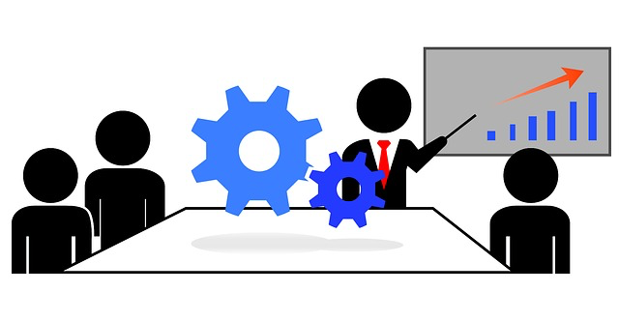
Speaking to Attract New Clients
WORKBOOK

Your Seminar Topics Team Member

1.

2.

3.

4.

5.

6.

7.

Event Checklist
- Title of Event

- Staff Leader of Event

- Date

- Event Start Time

- Event Ending Time

- Speakers

- Speaker Schedule

- Affiliate Partner(S)

- Invitations: mail and/or online

- # People to Invite

- Projected Attendance

- Objective of Event

- Venue (location or Zoom)

- Seminar Set-up

    - Sign-in Information
    - Capture E-mail Information
    - Room Set-Up
    - Other Speakers
    - After Seminar Event/Experience

ONLINE & IN-PERSON PLANS

Zoom In-Person: Location

Record Photographer
Microphone Microphone/Podium/Lapel
Lights Room Arrangement
Background Seating Arrangement
Show Participants Video Name Tags
List of Invitees Who Attend Table at Door for Name Tags
Tablecloth/Flowers on Table
Banner on Stage or near Podium
Company Signs/Banners
Photo Release Forms

Checklist for Physical Events

Items to Bring
- Laptop/mouse/power cord,
- Flashdrive with presentation on it
- Sign in sheet, name and email at minimum
- Resources to sell/giveaway (make a list so you have all of them)
- Display items – banners, posters
- Handouts - Feedback forms, action cards etc. (make a list
- Printed introduction (bio) for host to introduce you
- Business cards
- Cell phone and charger
- Camera, have person pre-arranged to photograph
- Extra batteries AA and AAA
- Safety pins
- Pens, tape, sharpies, post it notes, notepad
- Mints (you are talking to a lot of people before and after)

At Location
- Check AV equipment, use clicker. Get microphone attached, turn off after testing.
- Confirm photographer/videographer
- Connect with hotel contact
- Drink water well in advance, not a lot last minute
- Familiarize yourself with the speaking area/stage
- Put out feedback forms on chairs or tables
- Testimonials after – video/written

EVENT BUDGET

- Room Cost

- Food & Drink

- Mailed Invitations

- Photographer

- Banners

- Flowers

- Gifts for Participants

- Landing Page & Funnel

- Social Media Posts

PRE-EVENT PLANS

- What’s your FREE GIFT?

- When and how are you capturing your Prospect’s Name, E-mail and contact info.?

- How and when are you scheduling appointments for those individuals who are interested in speaking with you?

- What is your follow-up plan to stay in contact with your interested prospects?

Speak to Schedule Meeting Presentation

- Opening Presentation…capture their attention

- Intent of the Meeting

- Introduce the Company & Team

- Three Major Topics…Speak to Sell

- Invite them to meet with you…ONE CALL TO ACTION

- Ending of Presentation

Your Prospecting Strategy

Tracking & Planning Log

